Experiment 8

Name: Adwait S Purao

UID: 2021300101

Branch: Computer Engineering

Batch: B2

Verification of transformer performance by OC & SC Tests and by direct loading

# CIRCUIT DIAGRAM:

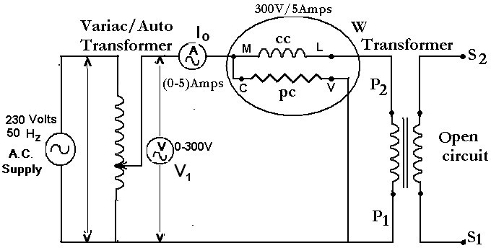**Part 1: Open Circuit (OC) Test**

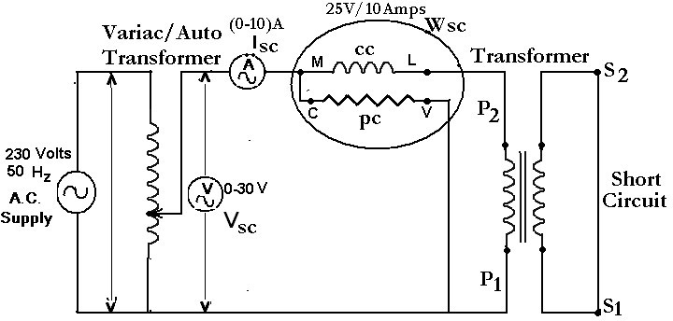**Part 2: Short Circuit (SC) Test**

**Part 3: Load Test**

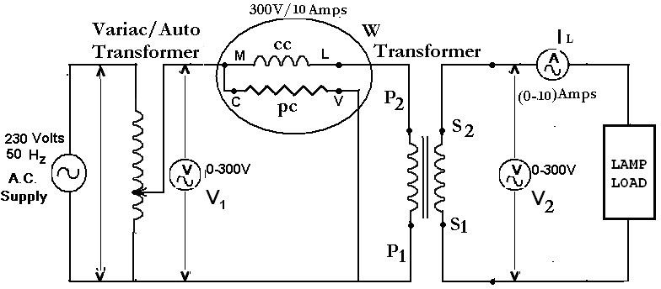

**EXPERIMENT No: 8 DATE: / / 2022**

**Verification of transformer performance by OC & SC Tests and by direct loading**

**AIM:** To perform Open circuit, short circuit, and load test on single phase 230V, 10A transformer for obtaining equivalent circuit, regulation and efficiency of transformer.

**APPARATUS AND COMPONENTS REQUIRED:**

1-Φ Auto transformer, Transformer (Rating), Ammeters (Range), Voltmeters (Range), Wattmeters (Rating), Lamp load, Connecting wires

**THEORY: Write theory related with following questions:**

1. Obtain equivalent circuit of transformer and draw the vector diagram.

**Equivalent circuit of a transformer**is a schematic representation of a practical transformer that shows all electrical parameters such as winding resistance, reactance, admittance, susceptance, primary and secondary voltages, currents etc. Now let’s dive into the topic and first of all, let’s get introduced to an actual transformer.

**Equivalent circuit of transformer**

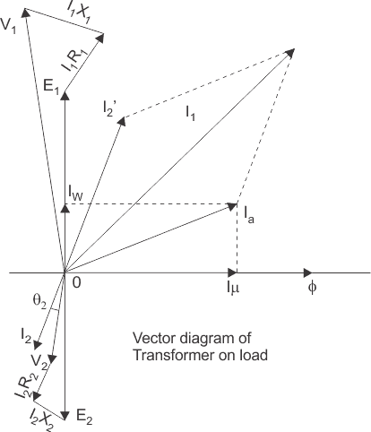

b) What is OC and SC test of transformer? How will it help to find the equivalent circuit of transformer?

Open Circuit Test(No-load Test) The purpose of this test is to determine no-load loss or core loss and noload I0 which is helpful in finding X0 and R0. One winding of the transformer – whichever is convenient but usually high voltage winding – is left open and the other is connected to its supply of normal voltage and frequency. A wattmeter W, voltmeter V and an ammeter A are connected in the low voltage winding. With normal voltage applied to this winding, normal flux will be set up in the core, hence normal iron losses will occur which are recorded by the wattmeter. As the primary no-load current I0 (as measured by ammeter) is small (usually 2 to 10% of rated load current), Cu loss is negligibly small in primary and nil in secondary (it being open). Hence, the wattmeter reading represents practically the core loss under no-load condition. It should be noted that since I0 is itself very small, the pressure coils of the wattmeter and the voltmeter are connected such that the current in them does not pass through the current coil of the wattmeter. Sometimes, a high-resistance voltmeter is connected across the secondary. The reading of the voltmeter gives the induced e.m.f. in the secondary winding. This helps to find transformation ratio K. If W is the wattmeter reading,

Short Circuit Test(Impedance Test) This test is used to determine to following:

(i) Equivalent impedance (Z01 or Z02), leakage reactance (X01 or X02) and total resistance (R01 or R02) of the transformer as referred to the winding in which the measuring instruments are placed.

(ii) Cu loss at full load (and at any desired load). This loss is used in calculating the efficiency of the transformer.

(iii) Knowing Z01 or Z02, the total voltage drop in the transformer as referred to primary or secondary can be calculated and hence regulation of the transformer determined. In this test, one winding, usually the low-voltage winding, is solidly short-circuited by a thick conductor. A low voltage (usually 5 to 10% of normal primary voltage) at correct frequency (though for Cu losses it is not essential) is applied to the primary and is cautiously increased till fullload currents are flowing both in primary and secondary (as indicated by the respective ammeters). Since, in this test, the applied voltage is a small percentage of the normal voltage, the mutual flux Φ produced is also a small percentage of its normal value. Hence, core losses are very small with the result that the wattmeter reading represent the full-load Cu loss or I2 R loss for the whole transformer i.e. both primary Cu loss and secondary Cu loss. If Vsc is the voltage required to circulate rated load currents, then Z01 = Vsc/I1

To know how to find equivalent circuit of transformer using OC and SC

From the open circuit test, we can determine the iron loss, magnetizing resistance and reactance. We can also find the active and reactive components of the no-load current. From the short circuit test, we can find the full load copper loss, equivalent resistance and reactance referred to primary or secondary side depending on which winding is short circuited.

c) Define regulation and efficiency of transformer.

The voltage regulation of the transformer is defined as the arithmetical difference in the secondary terminal voltage between no-load (I2=0) and full rated load (I2 = I2fl) at a given power factor with the same value of primary voltage for both rated load and no-load.

Transformer efficiency (η) can be explained as the ratio of the output power to the input power

d) How the parameters obtained from OC and SC test can help for calculation of efficiency and regulation of transformer?

From the open circuit test, we can determine the iron loss, magnetizing resistance and reactance. We can also find the active and reactive components of the no-load current. From the short circuit test, we can find the full load copper loss, equivalent resistance and reactance referred to primary or secondary side depending on which winding is short circuited. The efficiency of a transformer can be calculated by finding the ratio total output power upon total output power + copper loss + iron loss.

When a transformer is loaded, the secondary terminal voltage decreases due to a drop across secondary winding resistance and leakage reactance. This change in secondary terminal voltage from no load to full load conditions, expressed as a fraction of the no-load secondary voltage is called regulation of the transformer.

The expression of voltage regulation in terms voltage drops is given as

The above equations are used based on the parameters are referred to primary or secondary sides. Hence, from the SC test data we can find out the regulation of a transformer.

# PROCEDURE:

**OC Test**

1. Make connections as per the circuit diagram.
2. Adjust the autotransformer to the rated voltage of transformer (230V).
3. Record I0, V1 and Wi.
4. Set the autotransformer to zero position. Turn the power off and remove the connections for the circuit.

**SC Test**

1. Make connections as per the circuit diagram.
2. Make sure that the 1-Ф variable autotransformer (VARIAC) is kept in ZERO Position initially.
3. Turn the power on. Slowly vary the 1-Ф autotransformer (VARIAC) to set the current to rated current of transformer (10A).
4. Record V1, Isc and WCu.
5. Set the autotransformer to zero position. Turn the power off. Remove the connections for the circuit.

# OBSERVATION TABLE:

**For Part 1: OC Test**

**For Part 2: SC Test**

**Part3:LoadTest**

V1=V2=230V

# CALCULATIONS:

**For Open-Circuit Test**

Wi =V1I0cosØ0,

since, Wi, V1 & I0 can be obtained from the meters,

the no load power factor cosØ0= Wi / (V1I0) can be determine,

Iµ = I0sinØ0 and Iw = I0cosØ0 ; Hence, X0=V1/ Iµ & R0 = V1 / Iw

**For Short-Circuit Test**

Z01 = V1 / Isc

WCu = Isc2. R01; Hence R01 = WCu / Isc2 X01 = √(Z01)2 - (R01)2

**For Load Test**

## **% Regulation = (V2(0) −V2 x100) / V2(0)**

## **%Efficiency = (V2 I 2 x100) /W 1**

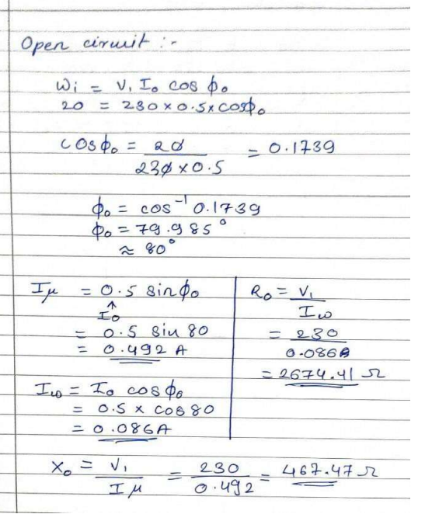

1

# 

# PROCEDURE:

**Load Test**

1. Connect the circuit as shown in the diagram.
2. Increase the input voltage to the transformer rated primary voltage.
3. Vary the lamp load in step from no load to the full load value.
4. Take the readings of the input wattmeter (W1), load current (IL) and load voltage (V2).
5. Calculate efficiency and regulation.
6. Plot percentage efficiency and regulation v/s load current.

# RESULT:

# 

**Graph for Efficiency vs IL and Regulation vs IL**

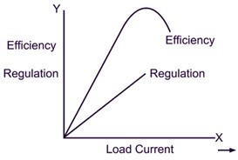

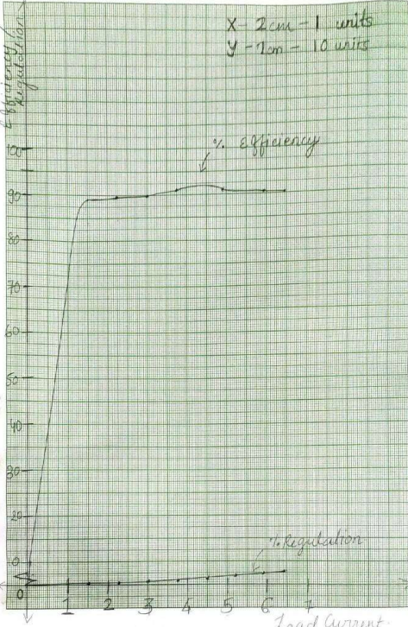

**CONCLUSION:**

